CENWP-OD-B 24 July 2023

MEMORANDUM FOR THE RECORD

SUBJECT: 23BON065 MFR Lamprey Mortality CI LPS RB3

On the morning of 24 July, Project Biologists discovered one adult Pacific Lamprey mortality in the Cascade Island LPS rest box number 3. The fish was scanned for PIT tags, inspected, and returned to the river.

- Species – Pacific Lamprey (Entosphenus tridentatus)
- Origin – Unknown
- Length – 57.2 cm
- Marks and tags – None
- Marks and Injuries found on carcass – None
- Cause and Time of Death – Unknown
- Future and Preventative Measures – None
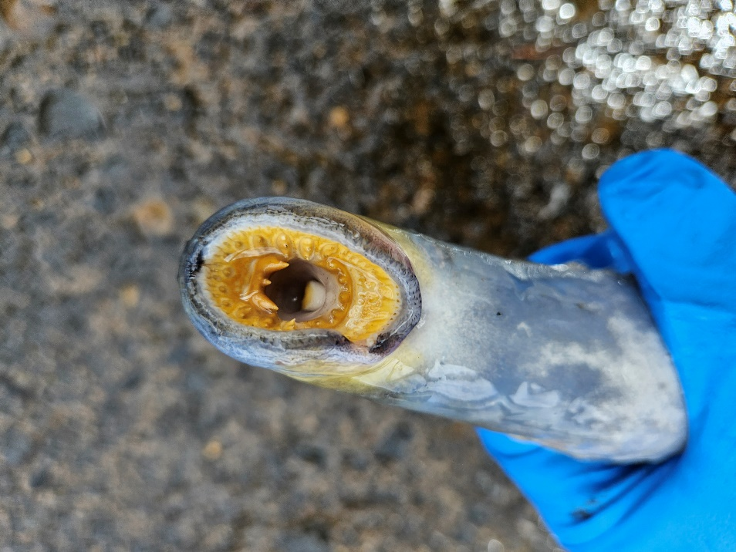
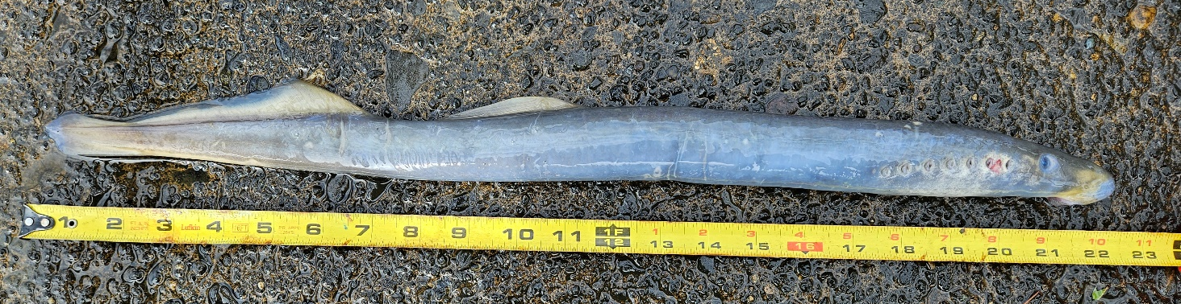

Sincerely,
BON Project Fisheries

